PLSQL
Exercise 1: Control Structures
Scenario 1:
BEGIN
FOR rec IN
(
SELECT CustomerID,
FLOOR(MONTHS_BETWEEN(SYSDATE,DOB)/12) Age
FROM Customers
)
LOOP
IF rec.Age > 60 THEN
UPDATE Loans
SET InterestRate = InterestRate - 1
WHERE CustomerID = rec.CustomerID;
DBMS_OUTPUT.PUT_LINE(
'Discount Applied to Customer '
|| rec.CustomerID
);
END IF;
END LOOP;
COMMIT;
END;
/
SELECT LoanID,CustomerID,InterestRate
FROM Loans;

Output: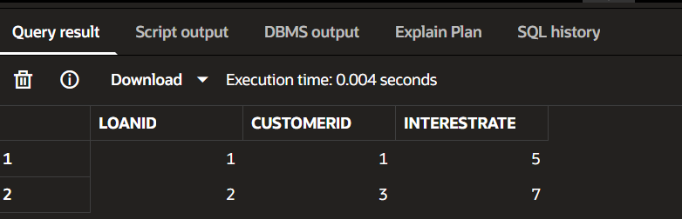
Scenario 2:
ALTER TABLE Customers
ADD IsVIP VARCHAR2(5);
BEGIN
FOR rec IN
(
SELECT CustomerID,Balance
FROM Customers
)
LOOP
IF rec.Balance > 10000 THEN
UPDATE Customers
SET IsVIP='TRUE'
WHERE CustomerID=rec.CustomerID;
DBMS_OUTPUT.PUT_LINE(
'VIP Customer: '
|| rec.CustomerID
);
ELSE
UPDATE Customers
SET IsVIP='FALSE'
WHERE CustomerID=rec.CustomerID;

END IF;
END LOOP;
COMMIT;
END;
/
SELECT CustomerID,Name,Balance,IsVIP
FROM Customers;
Result:
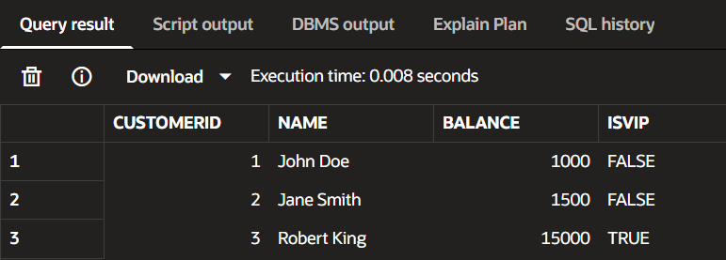 Scenario 3
BEGIN
FOR rec IN
(
SELECT c.Name,
l.LoanID,
l.EndDate
FROM Customers c
JOIN Loans l
ON c.CustomerID=l.CustomerID
WHERE l.EndDate BETWEEN SYSDATE
AND SYSDATE+30
)
LOOP

DBMS_OUTPUT.PUT_LINE(
'Reminder: Loan '
|| rec.LoanID
|| ' for '
|| rec.Name
|| ' due on '
|| TO_CHAR(rec.EndDate,'DD-MON-YYYY')
);

END LOOP;
END;
/
Output
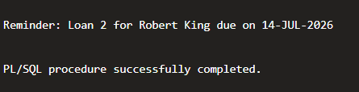

Exercise 2: Error Handling
Scenario 1
Create Procedure SafeTransferFunds
CREATE OR REPLACE PROCEDURE SafeTransferFunds(
p_from_account IN NUMBER,
p_to_account IN NUMBER,
p_amount IN NUMBER
)
IS
v_balance NUMBER;
BEGIN
SELECT Balance
INTO v_balance
FROM Accounts
WHERE AccountID = p_from_account;

IF v_balance < p_amount THEN
RAISE_APPLICATION_ERROR(
-20001,
'Insufficient Funds'
);
END IF;
UPDATE Accounts
SET Balance = Balance - p_amount
WHERE AccountID = p_from_account;

UPDATE Accounts
SET Balance = Balance + p_amount
WHERE AccountID = p_to_account;

COMMIT;
DBMS_OUTPUT.PUT_LINE('Transfer Successful');
EXCEPTION

WHEN OTHERS THEN
ROLLBACK;

DBMS_OUTPUT.PUT_LINE(
'Error: ' || SQLERRM
);
END;

/
SELECT * FROM Accounts;
Output:

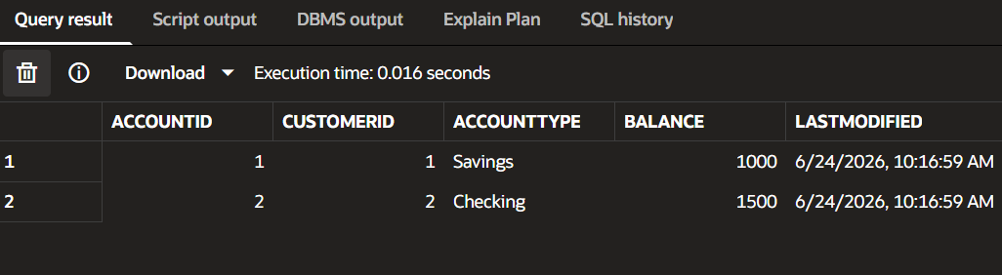
Successful Transfer
BEGIN
SafeTransferFunds(1,2,500);
END;
/
Output:

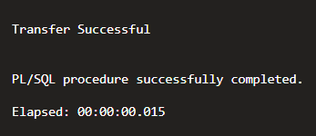;
Insufficient Funds Test
BEGIN
SafeTransferFunds(1,2,50000);
END;
/
Result:
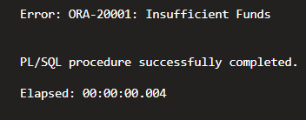
Scenario 2
CREATE OR REPLACE PROCEDURE UpdateSalary(
p_empid IN NUMBER,
p_percent IN NUMBER
)
IS
v_count NUMBER;
BEGIN
SELECT COUNT(*)
INTO v_count
FROM Employees
WHERE EmployeeID = p_empid;

IF v_count = 0 THEN
RAISE_APPLICATION_ERROR(
-20002,
'Employee ID Not Found'
);
END IF;
UPDATE Employees
SET Salary = Salary + (Salary * p_percent/100)
WHERE EmployeeID = p_empid;
COMMIT;
DBMS_OUTPUT.PUT_LINE(
'Salary Updated Successfully'
);
EXCEPTION
WHEN OTHERS THEN
DBMS_OUTPUT.PUT_LINE(
'Error: ' || SQLERRM
);
END;/
Successful Update
BEGIN
UpdateSalary(1,10);
END;
/
Output:
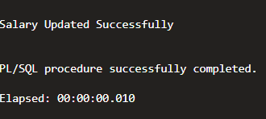

Invalid Employee Test
BEGIN
UpdateSalary(100,10);
END;
/
Result:
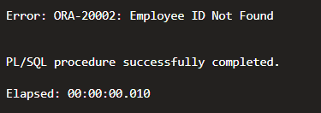
Scenario 3
create procedure:
CREATE OR REPLACE PROCEDURE AddNewCustomer(
p_customerid IN NUMBER,
p_name IN VARCHAR2,
p_dob IN DATE,
p_balance IN NUMBER
)
IS
BEGIN
INSERT INTO Customers
(
CustomerID,
Name,
DOB,
Balance,
LastModified
)
VALUES
(
p_customerid,
p_name,
p_dob,
p_balance,
SYSDATE
);
COMMIT;
DBMS_OUTPUT.PUT_LINE(
'Customer Added Successfully'
);
EXCEPTION
WHEN DUP_VAL_ON_INDEX THEN
DBMS_OUTPUT.PUT_LINE(
'Error: Customer ID Already Exists'
);
ROLLBACK;
WHEN OTHERS THEN

DBMS_OUTPUT.PUT_LINE(
'Error: ' || SQLERRM
);
ROLLBACK;
END;/
Step 2: Successful Insert
BEGIN
AddNewCustomer(
5,
'David Miller',
TO_DATE('1998-06-15','YYYY-MM-DD'),
3000
);
END;
/

Output

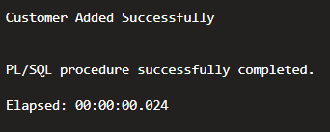 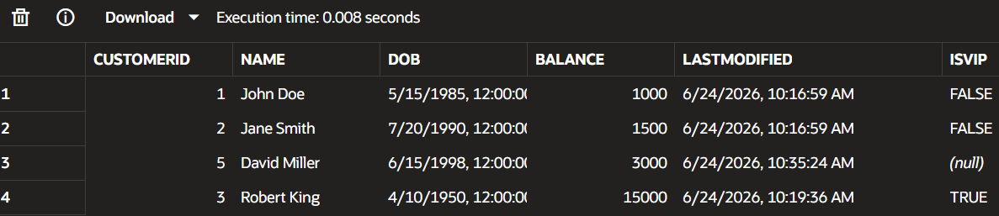
Duplicate ID Test
BEGIN
AddNewCustomer(
5,
'Another Customer',
TO_DATE('2000-01-01','YYYY-MM-DD'),
5000
);
END;
/

Output
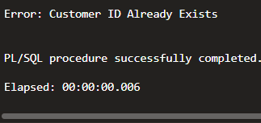

Exercise 3: Stored Procedures

Scenario 1
CREATE OR REPLACE PROCEDURE ProcessMonthlyInterest
IS
BEGIN
UPDATE Accounts
SET Balance = Balance + (Balance * 0.01),
LastModified = SYSDATE
WHERE AccountType = 'Savings';
COMMIT;
DBMS_OUTPUT.PUT_LINE(
'Monthly Interest Applied Successfully'
);
END;

/
Execute Procedure
BEGIN
ProcessMonthlyInterest;
END;
/

Output
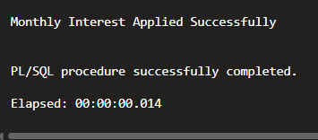

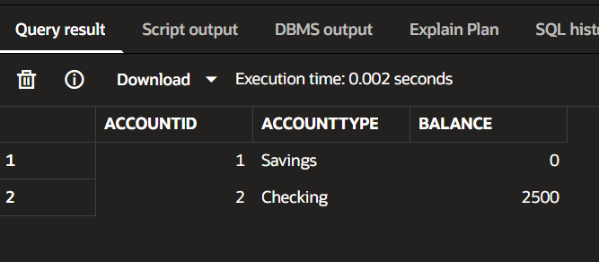
Scenario 2
CREATE OR REPLACE PROCEDURE UpdateEmployeeBonus(
p_department IN VARCHAR2,
p_bonus_percent IN NUMBER
)
IS
BEGIN

UPDATE Employees
SET Salary = Salary +
(Salary * p_bonus_percent / 100)
WHERE Department = p_department;

COMMIT;

DBMS_OUTPUT.PUT_LINE(
'Bonus Applied Successfully'
);

END;
/
SELECT EmployeeID,
Name,
Department,
Salary
FROM Employees;
Result:

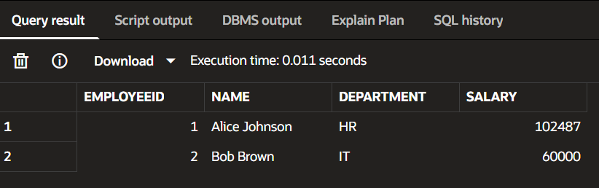 Execute Procedure
BEGIN
UpdateEmployeeBonus('IT',10);
END;
/

Output

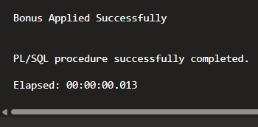

Verify
SELECT EmployeeID,
Name,
Department,
Salary
FROM Employees;
output:
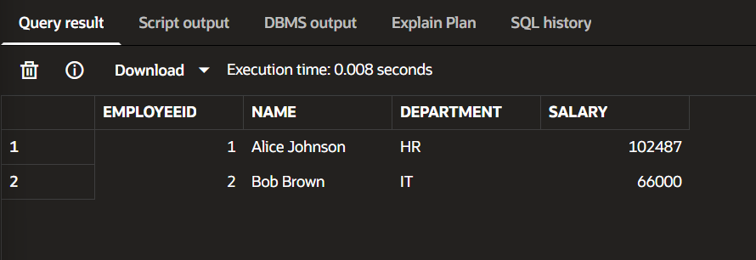
Scenario 3
CREATE OR REPLACE PROCEDURE TransferFunds(
p_from_account IN NUMBER,
p_to_account IN NUMBER,
p_amount IN NUMBER
)
IS
v_balance NUMBER;
BEGIN

SELECT Balance
INTO v_balance
FROM Accounts
WHERE AccountID = p_from_account;

IF v_balance < p_amount THEN

DBMS_OUTPUT.PUT_LINE(
'Insufficient Balance'
);

ELSE

UPDATE Accounts
SET Balance = Balance - p_amount
WHERE AccountID = p_from_account;

UPDATE Accounts
SET Balance = Balance + p_amount
WHERE AccountID = p_to_account;
COMMIT;
DBMS_OUTPUT.PUT_LINE(
'Transfer Successful'
);
END IF;
END;

/
Step 2: Check Balances
SELECT AccountID,
Balance
FROM Accounts;
Before
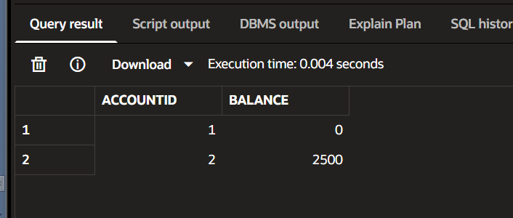

Step 3: Execute Procedure
BEGIN
TransferFunds(1,2,500);
END;
/
SELECT AccountID,
Balance
FROM Accounts;

Output

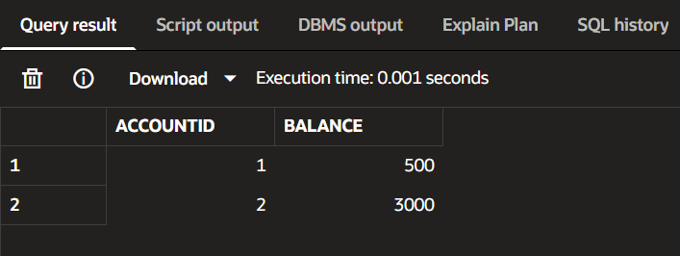
Test Insufficient Balance
BEGIN
TransferFunds(1,2,10000);
END;
/

Output
